Steps Followed:

1. Creating instances :
2. Go to AWS EC2 console and click Launch Instance
3. Now choose the AMI of your choice ( we choose Ubuntu Server 16.04 LTS (HVM), SSD Volume Type - ami-a58d0dc5)
4. Choose the type of instance (we choose m4.xlarge)
5. 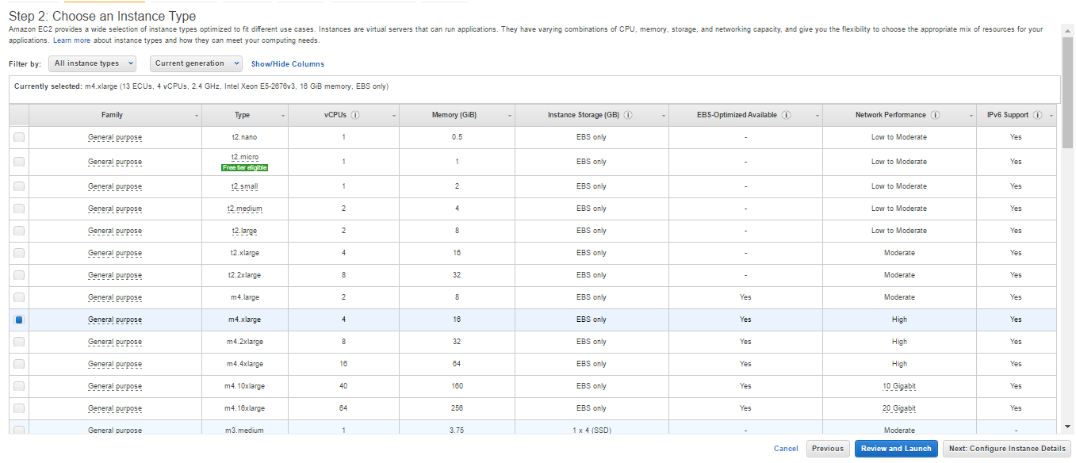Configure the instance details:
6. Configuration 1: Cassandra cluster with 1 node: use 2 instances (1 for Cassandra and 1 for YCSB)
7. Configuration 2: Cassandra cluster with 3 nodes: use 4 instances (3 for Cassandra and 1 for YCSB)
8. Configuration 3: Cassandra cluster with 6 nodes: use 7 instances (6 for Cassandra and 1 for YCSB)

(NOTE: snip below shows configuration 3 i.e. we will launch 7 instances)

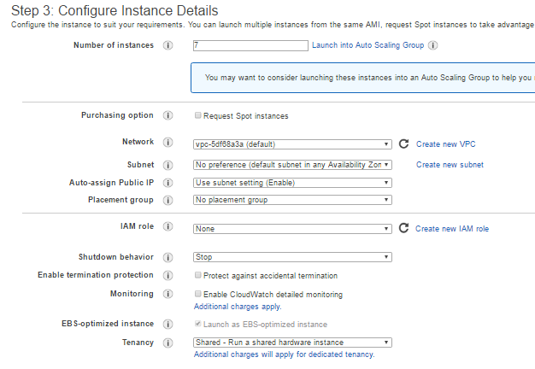

1. Add Storage (we choose 30 GiB)
2. Connect the created instances via Putty using the Public IP for each respective instance and Secure Key Pair that we have used during the creation of the instance.
3. Inbound/Outbound Rules: (we choose it as anywhere so that we can connect freely without any restrictions, you may configure your security group features as per your requirements)

(NOTE : snip below shows Security group rules associated with one of our instance)

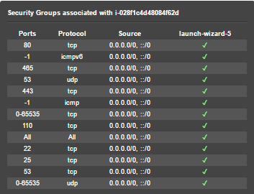

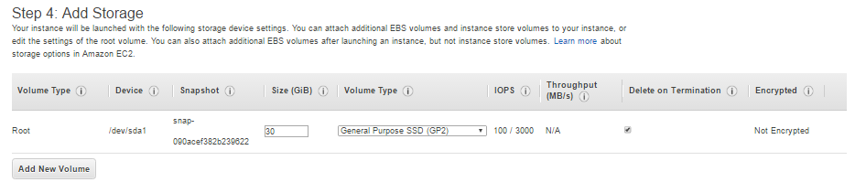

1. Working on instance via Putty (shows all nodes that are working with Cassendra)

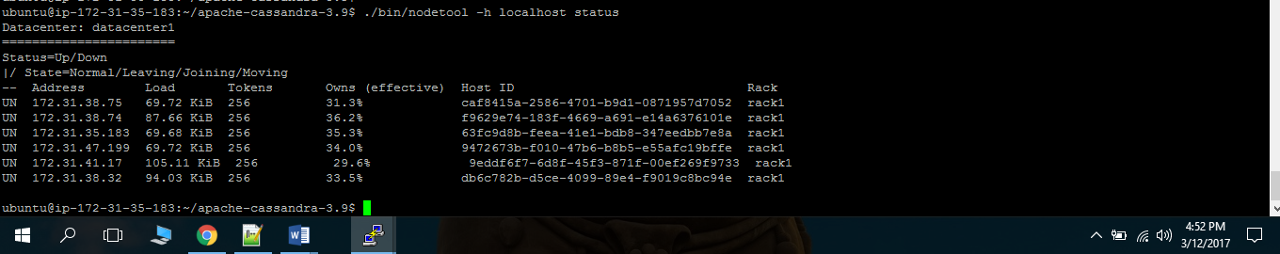

1. Creating replication tables in Cassendra : (we choose 1 node set replication factor as 1 , set it 2 for 2 nodes and 6 for 6 nodes)

(NOTE : snip below shows the table definition)

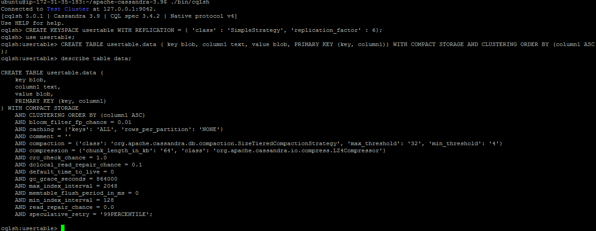

Steps for Running Cassandra on Ec2 instance:

1. Choose your version of Cassandra (we choose 3.9)

curl -OL <http://www.apache.org/dist/cassandra/3.9/apache-cassandra-3.9-bin.tar.gz>

tar xzf apache-cassandra-3.9-bin.tar.gz

1. Install Java
2. Install Python
3. Run Cassandra through given commands as below :

cd/apache-cassandra-3.2.1/  
bin/cassandra -R

/bin/nodetool -h localhost status

YCSB commands are as under:

* ./bin/ycsb load cassandra-10 -P workloads/workload_test10 -p hosts=172.31.44.1 -threads 10 -p columnfamily=data -s > results_Cassandra/load_10
* ./bin/ycsb run cassandra-10 -P workloads/workload_test10 -p hosts=172.31.44.1 -threads 10 -p columnfamily=data -s > results_Cassandra/run_10
* ./bin/ycsb load cassandra-10 -P workloads/workload_test40 -p hosts=172.31.44.1 -threads 10 -p columnfamily=data -s > results_Cassandra/load_40
* ./bin/ycsb run cassandra-10 -P workloads/workload_test40 -p hosts=172.31.44.1 -threads 10 -p columnfamily=data -s > results_Cassandra/run_40
* ./bin/ycsb load cassandra-10 -P workloads/workload_test80 -p hosts=172.31.44.1 -threads 10 -p columnfamily=data -s > results_Cassandra/load_80
* ./bin/ycsb run cassandra-10 -P workloads/workload_test80 -p hosts=172.31.44.1 -threads 10 -p columnfamily=data -s > results_Cassandra/run_80
* ./bin/ycsb load cassandra-10 -P workloads/workload_test160 -p hosts=172.31.44.1 -threads 10 -p columnfamily=data -s > results_Cassandra/load_160
* ./bin/ycsb run cassandra-10 -P workloads/workload_test160 -p hosts=172.31.44.1 -threads 10 -p columnfamily=data -s > results_Cassandra/run_160
* ./bin/ycsb load cassandra-10 -P workloads/workload_test320 -p hosts=172.31.44.1 -threads 10 -p columnfamily=data -s > results_Cassandra/load_320
* ./bin/ycsb run cassandra-10 -P workloads/workload_test320 -p hosts=172.31.44.1 -threads 10 -p columnfamily=data -s > results_Cassandra/run_320
* ./bin/ycsb load cassandra-10 -P workloads/workload_test640 -p hosts=172.31.44.1 -threads 10 -p columnfamily=data -s > results_Cassandra/load_640
* ./bin/ycsb run cassandra-10 -P workloads/workload_test640 -p hosts=172.31.44.1 -threads 10 -p columnfamily=data -s > results_Cassandra/run_640

**Benchmark Observations (AWS EC2)**

|  |  |  |  |  |
| --- | --- | --- | --- | --- |
| #1 nodes |  |  |  |  |
| concurrent users | load | | run | |
|
| RunTime(ms) | Throughput(ops/sec) | RunTime(ms) | Throughput(ops/sec) |
| 10 | 19672 | 12990.54494 | 8886 | 11253.65744 |
| 40 | 37447 | 15211.3654 | 26430 | 15134.31706 |
| 80 | 70700 | 13937.36917 | 63522 | 12594.0619 |
| 160 | 130384 | 13855.76451 | 158556 | 10091.07192 |
| 320 | 247471 | 13770.2357 | 291366 | 10982.75022 |
| 640 | 480565 | 13411.57804 | 2380461 | 2688.554864 |
|  |  |  |  |  |
| # 3 nodes |  |  |  |  |
| concurrent users | load | | run | |
|
| RunTime(ms) | Throughput(ops/sec) | RunTime(ms) | Throughput(ops/sec) |
| 10 | 28137 | 9082.347087 | 13161 | 7598.206823 |
| 40 | 49548 | 11496.32679 | 36362 | 11000.49502 |
| 80 | 90774 | 10855.22286 | 81743 | 9786.770733 |
| 160 | 177056 | 10203.38198 | 176318 | 9074.513096 |
| 320 | 355224 | 9593.197532 | 371858 | 8605.435408 |
| 640 | 689910 | 9341.993883 | 1037578 | 6168.210968 |
|  |  |  |  |  |
|  |  |  |  |  |
|  |  |  |  |  |
| # 6 nodes |  |  |  |  |
| concurrent users | load | | run | |
|
| RunTime(ms) | Throughput(ops/sec) | RunTime(ms) | Throughput(ops/sec) |
| 10 | 38342 | 6665.014866 | 15148 | 6601.531555 |
| 40 | 72479 | 7859.104016 | 45702 | 8752.352195 |
| 80 | 131366 | 7500.966765 | 96136 | 8321.544479 |
| 160 | 240137 | 7523.080575 | 214151 | 7471.363664 |
| 320 | 456853 | 7459.147691 | 420728 | 7605.864121 |
| 640 | 898313 | 7174.709706 | 1161273 | 5511.19332 |

**Problems faced**

1. We tried working the same set of commands on Cassandra’s 3.10 version but found that commonds didn’t worked out and same set of commands worked fine on Cassandra’s 3.9 version
2. Cassandra YCSB are case sensitive for e.g :

./bin/ycsb load cassandra-10 **-P** workloads/workload_test10 -p hosts=172.31.44.1 -threads 10 -p columnfamily=data -s > results_Cassandra/load_10

Highlighted P doesn’t work if it is small case. We have to debug the command and came to conclusion that commands are case sensitive.

1. Changing the Cassandra configuration file totally varies on what version of Cassandra you are using we have to look for online help to get through the .yaml file configuration
2. YCSB commands executed in different manner ; might be because of network bandwidth
3. Given set of YCSB not compatible with current version of YSCB i.e. yscb-0.12.0 hence we have to switchback to ycsb-0.3.0